Request for Authorization

Project: Remote Weather Station

Members:
- Abdullah Ali
- Ben Rogers
- Christian Evans
- Gantzen Miller
- Kennedy Jones
- Pete Ozegovic

Project Overview:
Something people experience every day is the environment around us. How hot or cold it is outside, how much it rained, the UV index to see if we need more sunscreen and the list goes on. One way we measure and keep track of these environmental factors is to use a combination of sensors. For this project, we are working with the KSU Mesonet staff to make a remote weather station that can log data and transmit the findings across the state. The current system that the KSU Mesonet has is very expensive, so taking a different approach on design and cost could benefit the staff in making a more cost-efficient system that can be maintained and mass produced to cover a large amount of area in Kansas.

Estimated Budget and Goals:
Current Station ~ $19,000
Sensors - ~$200
Board/Modem - ~$200
Packaging/Mechanical - ~$200
Rough Range - ~$600
Project Description:
The Project goal is to make a weather station that can take measurements of the area around the station. The general flow of the station is shown below in Figure 2. It shows that we need to collect data for the following parameters:
- Air Temperature
- Humidity
- Solar Radiation
- Wind Speed/Direction
- Precipitation
- Pressure
- Soil Temperature
- Soil Moisture
- Air Quality
The measurements will be taken with a microcontroller (probably ESP32) and then wirelessly transmit the data. We will then receive the data on a nice user interface (most likely some home assistant). We also need to power this system with a battery and solar charger.

Project Flow:
For this station, I made the flow diagram below in Figure 1 that shows the main priorities that need to be completed. After that we can shift focus to the Addons and Secondary Priorities. Some of the secondary priorities and addons can be solved with the main priorities. Example: The size of the station could be small enough to make the substation network with the same station excluding the cell modem.

Visual Figures for Project
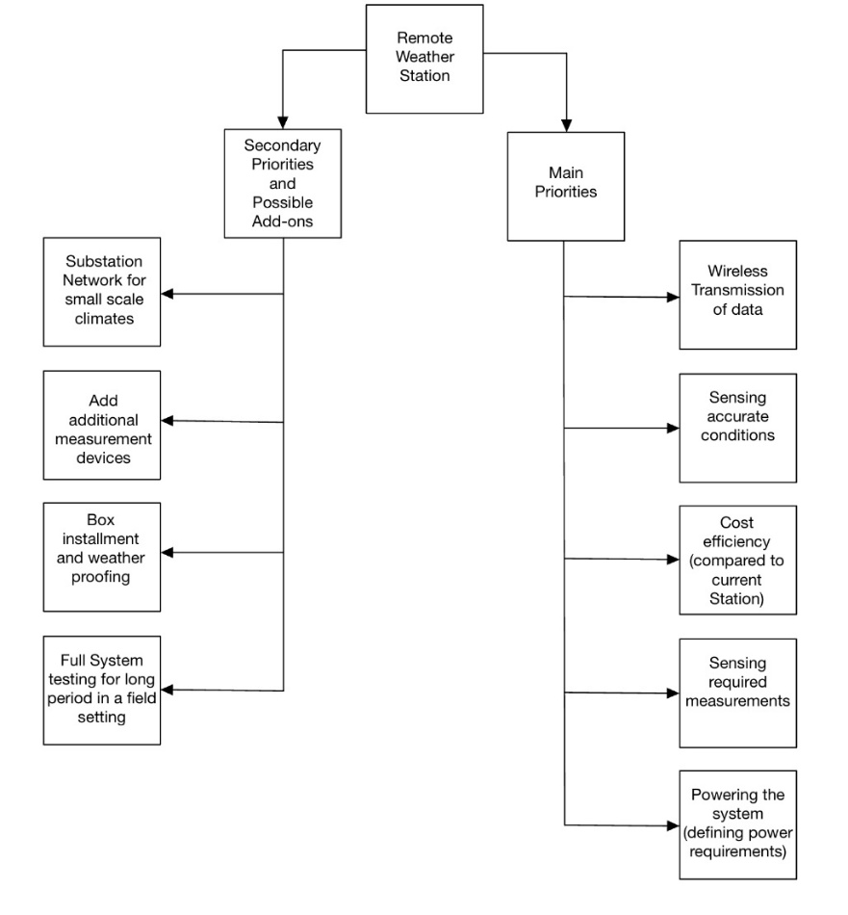
Figure 1: Project Flow
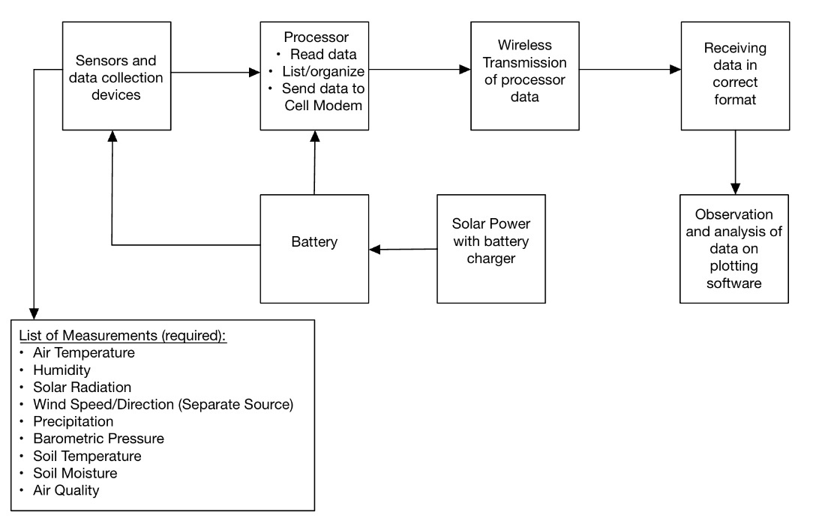
Figure 2: System Operation

